Assignment 1 Example

Problem 1:

The first five numbers in your Gaussian data set are:
-12.89 | -5.67 | -2.60 | -1.54 | -0.31

Sample mean = 8.114650
Sample standard deviation = 4.812293
The five number summary is:
-12.89 | 5.36 | 7.815 | 11.320 | 20.770

Sample median = 7.815
Range = 20.770 – (-12.89) = 33.66
IQR = 11.32 – 5.36 = 5.96
Sample skewness = -0.2029152
Sample kurtosis = 4.486426
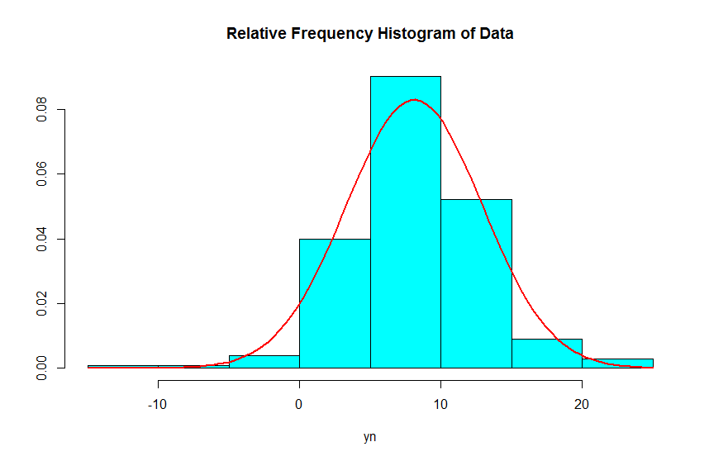
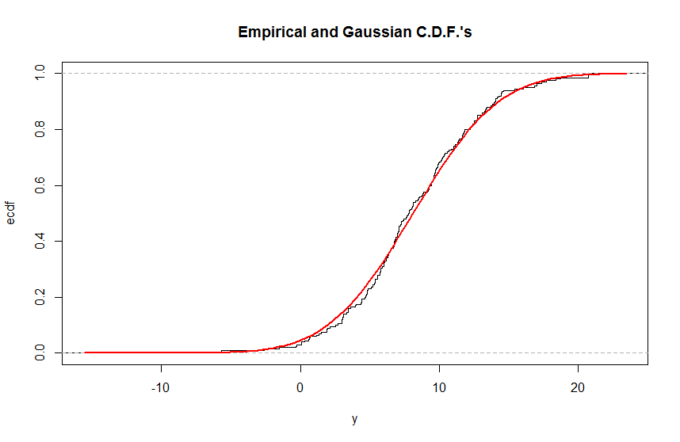

Problem 2: The first five numbers in your Exponential data set are:
0.01 | 0.13 | 0.18 | 0.24 | 0.26

Sample mean = 7.916900
Sample standard deviation = 9.249768
The five number summary is:
0.010 | 2.070 | 5.095 | 11.120 | 90.520

Sample median = 5.095
Range = 90.520 – 0.010 = 90.51
IQR = 11.120 – 2.070 = 9.05
Sample skewness = 4.198336
Sample kurtosis = 33.82573

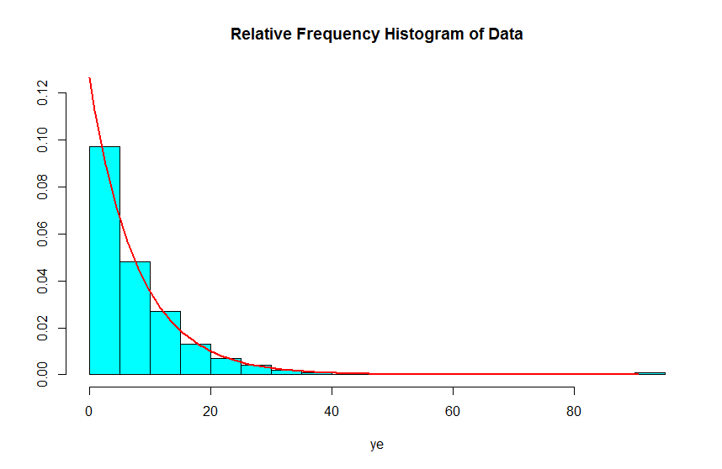
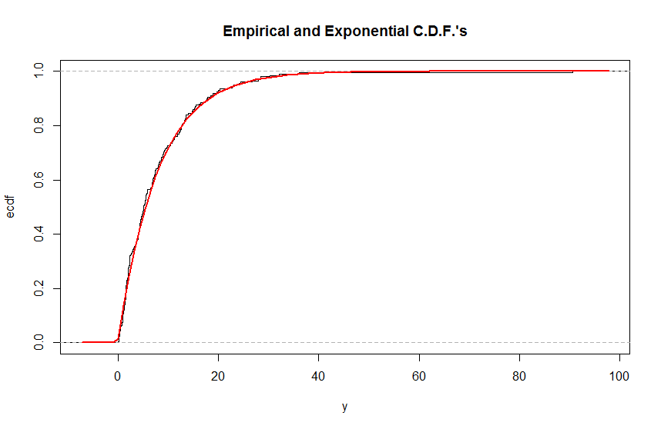

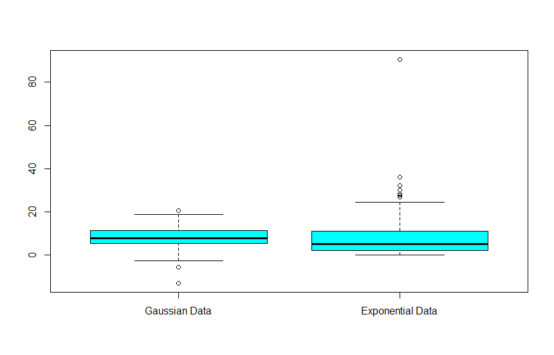

Problem 3:
Alpha = 8.11465 Beta = 7.9169
The first five pairs of numbers in your bivariate data set are:
x | y
1.1 | 24.1
1.9 | 14.9
8.5 | 64.1
15.5 | 136.9
19.6 | 156.0

Sample Correlation = 0.9365159

